BILL NO. | AB 277 | AB 335 | AB 378 | AB 414
ACTION VOTED ON | Do pass and re-refer to the Committee on Appropriations with the recommendation: To consent calendar | Do pass and re-refer to the Committee on Appropriations | Do pass and be ordered to the consent calendar | Do pass and re-refer to the Committee on Governance and Finance with the recommendation: To consent calendar
 | Aye : No | Aye : No | Aye : No | Aye : No
Umberg, Chair | X : | X : | X : | X :
Borgeas, V. Chair | X : | X : | X : | X :
Caballero | X : | X : | X : | X :
Durazo | X : | X : | X : | X :
Gonzalez | X : | X : | X : | X :
Hertzberg | X : | X : | X : | X :
Jones | X : | X : | X : | X :
Laird | X : | X : | X : | X :
Stern | X : | X : | X : | X :
Wieckowski | X : | X : | X : | X :
Wiener | X : | X : | X : | X :
 | Ayes : 11 | Ayes : 11 | Ayes : 11 | Ayes : 11
 | Noes : 0 | Noes : 0 | Noes : 0 | Noes : 0

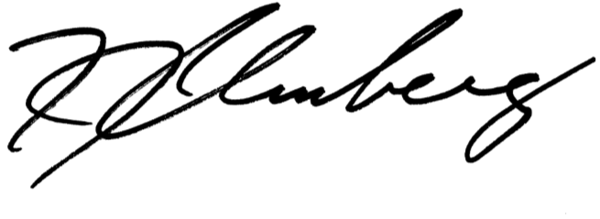

Date of Hearing: 06/08/2021 _______________________________________________, Chair

BILL NO. | AB 429 | AB 453 | AB 556 | AB 627
ACTION VOTED ON | Do pass and re-refer to the Committee on Appropriations with the recommendation: To consent calendar | Do pass and re-refer to the Committee on Appropriations with the recommendation: To consent calendar | Do pass and re-refer to the Committee on Appropriations | Do pass and re-refer to the Committee on Appropriations with the recommendation: To consent calendar
 | Aye : No | Aye : No | Aye : No | Aye : No
Umberg, Chair | X : | X : | X : | X :
Borgeas, V. Chair | X : | X : | X : | X :
Caballero | X : | X : | X : | X :
Durazo | X : | X : | X : | X :
Gonzalez | X : | X : | X : | X :
Hertzberg | X : | X : | X : | X :
Jones | X : | X : | X : | X :
Laird | X : | X : | X : | X :
Stern | X : | X : | X : | X :
Wieckowski | X : | X : | X : | X :
Wiener | X : | X : | X : | X :
 | Ayes : 11 | Ayes : 11 | Ayes : 11 | Ayes : 11
 | Noes : 0 | Noes : 0 | Noes : 0 | Noes : 0

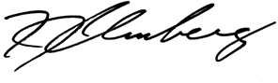

Date of Hearing: 06/08/2021 _______________________________________________, Chair

BILL NO. | AB 841 | AB 855 | AB 891 | AB 1391
ACTION VOTED ON | Do pass as amended and be ordered to the consent calendar | Do pass and re-refer to the Committee on Appropriations | Do pass and be ordered to the consent calendar | Do pass and re-refer to the Committee on Public Safety
 | Aye : No | Aye : No | Aye : No | Aye : No
Umberg, Chair | X : | X : | X : | X :
Borgeas, V. Chair | X : | X : | X : | X :
Caballero | X : | X : | X : | X :
Durazo | X : | X : | X : | X :
Gonzalez | X : | X : | X : | X :
Hertzberg | X : | X : | X : | X :
Jones | X : |  | X : | X :
Laird | X : | X : | X : | X :
Stern | X : | X : | X : | X :
Wieckowski | X : | X : | X : | X :
Wiener | X : | X : | X : | X :
 | Ayes : 11 | Ayes : 10 | Ayes : 11 | Ayes : 11
 | Noes : 0 | Noes : 0 | Noes : 0 | Noes : 0

Date of Hearing: 06/08/2021 _______________________________________________, Chair

BILL NO. | AB 1579 | AB 1580
ACTION VOTED ON | Do pass and be ordered to the consent calendar | Do pass and be ordered to the consent calendar
 | Aye : No | Aye : No | Aye : No | Aye : No
Umberg, Chair | X : | X :
Borgeas, V. Chair | X : | X :
Caballero | X : | X :
Durazo | X : | X :
Gonzalez | X : | X :
Hertzberg | X : | X :
Jones | X : | X :
Laird | X : | X :
Stern | X : | X :
Wieckowski | X : | X :
Wiener | X : | X :
 | Ayes : 11 | Ayes : 11 | Ayes : 0 | Ayes : 0
 | Noes : 0 | Noes : 0 | Noes : 0 | Noes : 0

Date of Hearing: 06/08/2021 _______________________________________________, Chair

